Lab Manual

Name : Iman Ishar
Roll No : 2410040305-010
Degree : BS Computer Science
Subject : Information security lab
Semester : Third



Submitted to Mam Ayesha
Grand Asian University Sialkoat

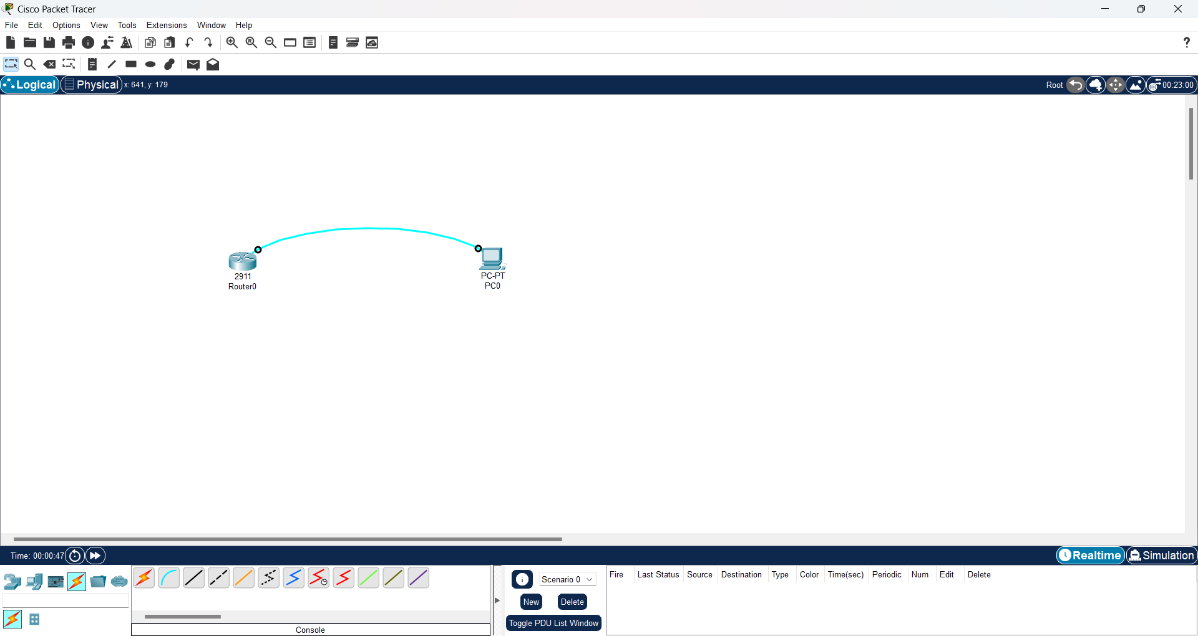

First drag router 2911 then pc
Join them together with console cable
Click on the PC then select Desktop tab then open Terminal.
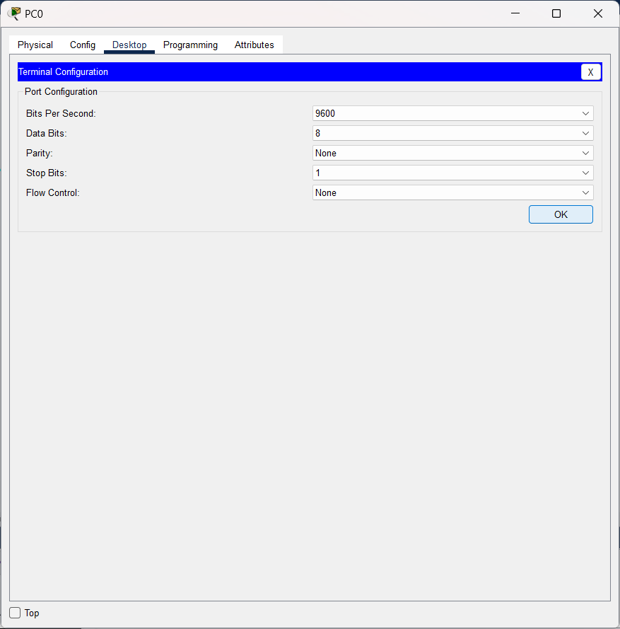
Then click ok button
You’ll see Router>
Type Router> ? and press Enter
Then you’ll see commands
Type Router> show running-config and press Enter

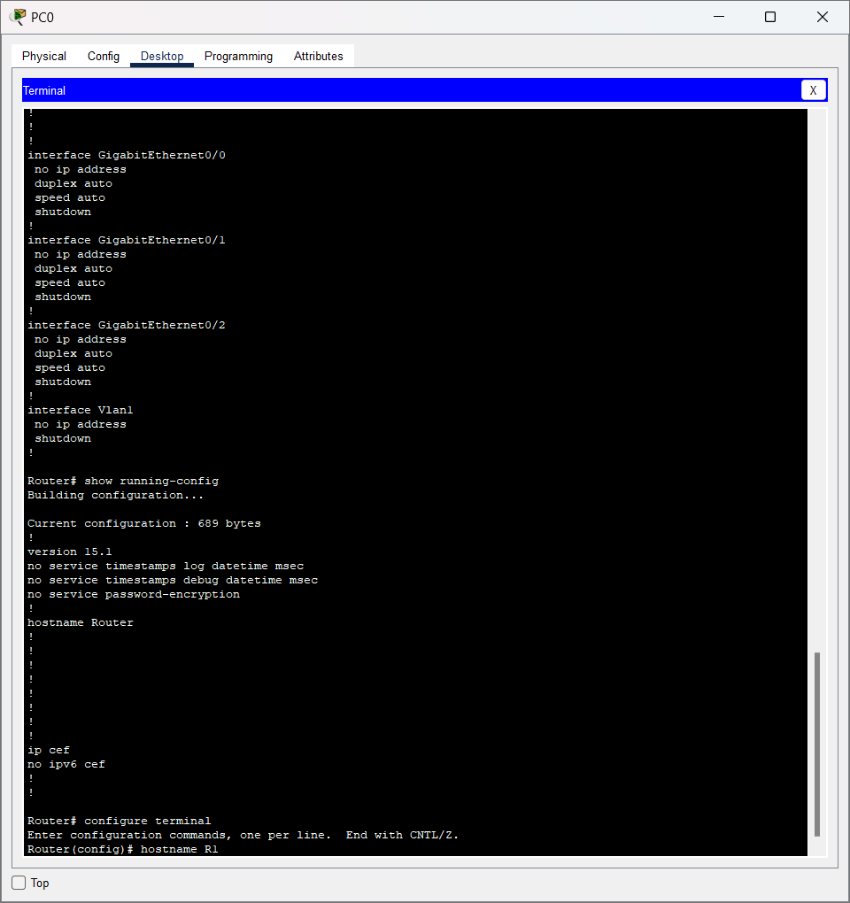

Now type these commands and enter then one by one
Router> enable
Prompt changes to:
Router#
Router# show running-config
Router# configure terminal
Router(config)# hostname R1
R1(config)#
now set password and encrypt it
R1(config)# enable password cisco123
R1(config)# enable secret Secure@123
Now set console password and enter these commands
R1(config)# line console 0
R1(config-line)# password console@123
R1(config-line)# login
R1(config-line)# exit

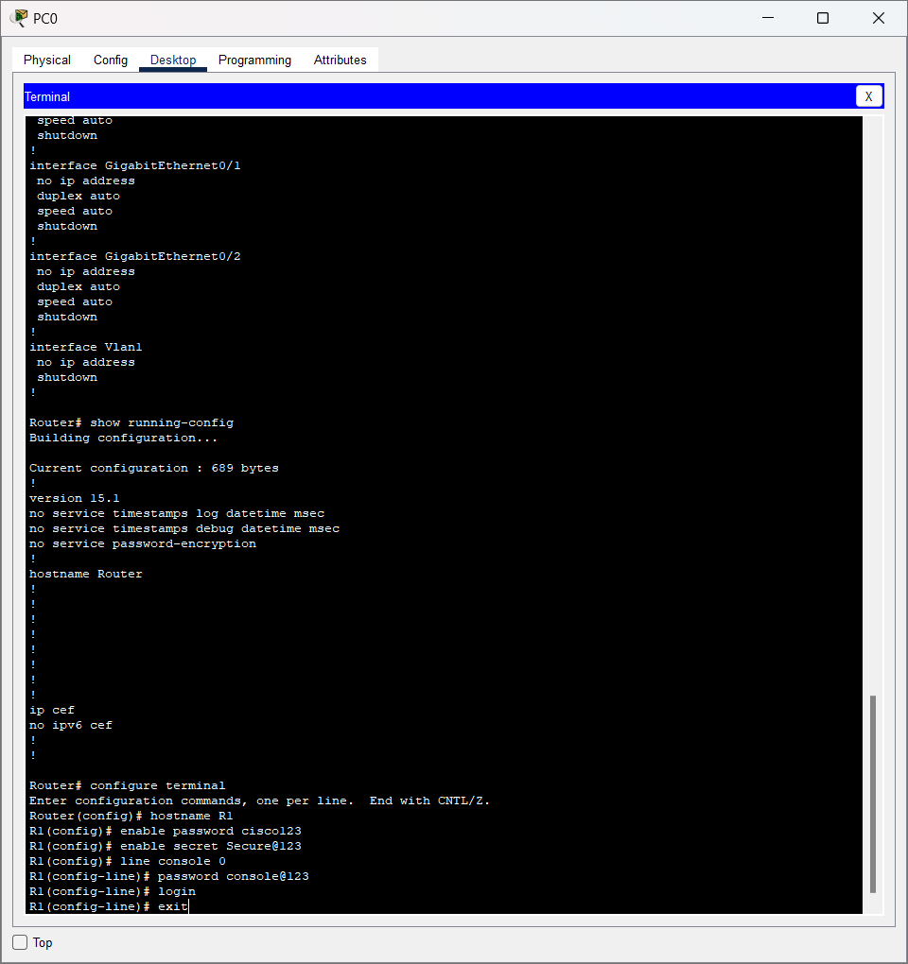

Now type these
R1(config)# username admin privilege 15 secret Admin@123
R1(config)# username user privilege 1 secret User@123
This allows login with username/password instead of only console password.
Now Configure Console to Use Local Login
R1(config)# line console 0
R1(config-line)# login local
R1(config-line)# exit
R1# copy running-config startup-config
Destination filename [startup-config]? (press Enter)
Now save this
R1# write memory
R1# exit

